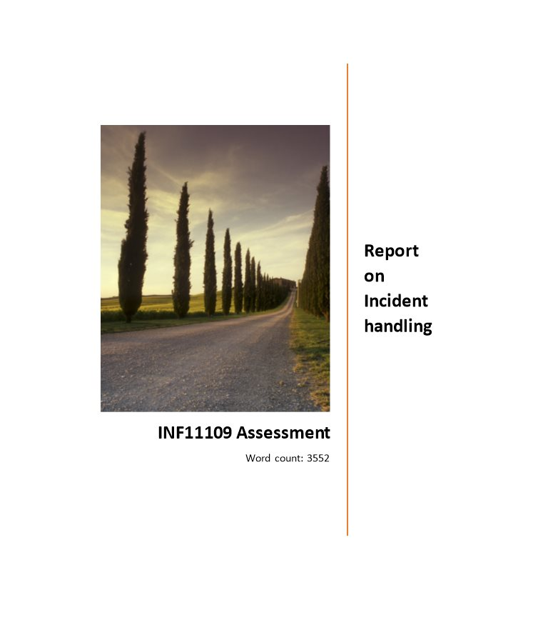

# Report

# Executive summary

Data and Information security may be a top concern for business organizations, as investigate finds that cyber-attacks are propelled 2,244 times a day—that’s each 39 seconds. The part of Chief Data Security Officer (CISO) is picking up notoriety to secure against information security risks. Considerable inquire about has been finished, with a centre on the steps fundamental to make and organize an Occurrence Dealing with Team in huge organizations, but the assets required for such a venture don't scale down to anything usable by the Little Trade community. This report audits current best hones within the security community, and proposes a best demonstrate that scales these steps into something workable and worthy to the community.

# Introduction

Government organizations and other firms now started of expanding their computer safety and security endeavors since of expanded dangers in terms of computer data. Occurrences including lots of dangers, such aas computer infections, pernicious client movement, and vulnerabilities associated with tall innovation, require a gifted and fast reaction some time recently they can cause critical harm. (Killcrece, Kossakowski, Ruefle, & Zajicek, 2003; Wack, 1991)

These issues now increased computer security endeavors, depicted the Computer Security Occurrence Reaction Capabilities and responsibilities (CSIRCs), have its essential focus to their objective of responding rapidly and effectively to computer security occurrences. (Tan, Ruighaver, & Ahmad, 2003; Wack, 1991)CSIRC endeavours give organizations having a low cost for taking care of computer safety episodes so the upcoming issues are effectively settled , sorted and protected.(Jalal, Yusof, Shukur, & Mokhtar)

Whereas the attacks to computer security have now increased, offices now too gotten to be great number subordinate on computers. There are lots of framework widespread uses nowadays that don't have shelter to safe assurance from these threats. Furthermore, a frameworks gotten now more complex,there are lots of inclined to vulnerabilities that now increment hazard of noxious misuse. Due to the large numbe of availability of computers, clients regularly used framework directors, in any case numerous have not one or the other the imperative aptitudes nor time to manage their frameworks successfully. (Schultz Jr, Brown, & Longstaff, 1990)These components make it clear that organizations got to increase their computer security capabilities before they endure from genuine computer security threats that can disturb their missions,that's why the result is in a very critical cost, and discolour their images.(Creasey, 2013)

A CSIRC aid offices resolve computer safety and security issues in suh a way that's both productive and low cost-efficient. It is connected with centralized dealing and detailing, a CSIRC now decrease squander and redundancy when providing distant pose against possibly devastating dangers.(Tan et al., 2003) A CSIRC may be a superb way to prevent computer frrom threate, one can  manage responsive responsibilities with efficient manners to anticipate the upcoming episodes from present.(Killcrece et al., 2003)

# Proposed Various Models

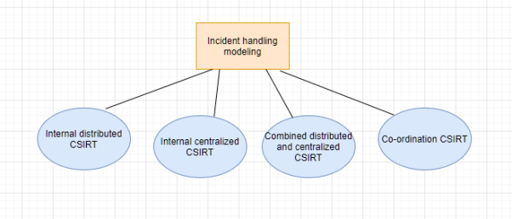

## Internal Distributed CSIRT

 In this illustrate, the organization uses already experienced staff to supply a  scattered organization, that is standardly design that bargain the occurrence results works out. There's a administrator who oversees and encourages works out for the passed on group. Over the organization, individuals are recognized as the reasonable centers for working as parcel of the dispersed group based on  ability with distinctive working framework stages, propels, and applications; or based on their geographic area or utilitarian obligations. (Cichonski, Millar, Grance, & Scarfone, 2012; Creasey, 2013)The dispersed gather people can do CSIRT commitments in expansion to their standard duties.

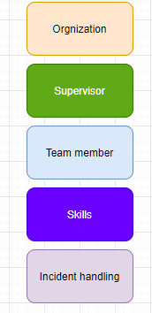

## Internal Centralized CSIRT

This appear may be a totally staffed, committed CSIRT that provide the event managing with organizations for an aadmnistration. In various cases bunch individuals spend 100% of their hardworking for the CSIRT; be that as it may, this sort of appear might in addition be given utilizing evening-time staff on a transformation preface. (Ruefle et al., 2014; Scarfone, Grance, & Masone, 2008)There's a CSIRT chief who reports to higher organization . This gathering is centrally found inside the firm and that is careful for every event taking care of works out over the voting open or endeavor.

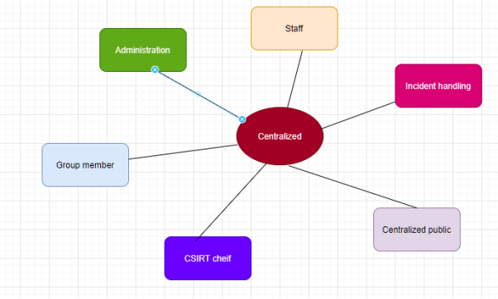

## Distributed and Centralized Organization

It illustrate talks to a complete mixture of those scattered organization and the distributed organization. (Schultz Jr et al., 1990; Tan et al., 2003)It utilizes the uses of already working people in key zones in all the administration along with collectively find arranging responsibilities of all the committed gather to deliver a and a detailed understanding of the organization that is related to the security threats. This model focused on the centralized strictures so it follows or it must require to keep both the interior and exterior parts of the organization(Scarfone et al., 2008)

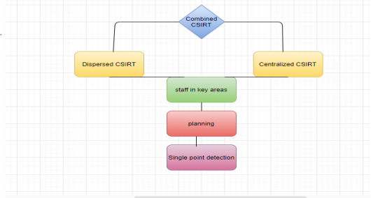

## Coordination of organization

This appear that organization orchestrates and the empowers that taking care of events over a grouping of exterior or inward firms, which appear join other CSIRTs. The CSIRT can be a arranging substance for individual reinforcements of an organization, various sectors of a military organization, teach in a examine orchestrate or space, or for distinctive organizations interior a specific country or state. (Ab Rahman & Choo, 2015)

Arranging CSIRTs regularly have distinctive voting public. What makes this illustrate special is the set of organizations given and how they are custom fitted towards making a distinction other organization deal with event taking care of issues. (Creasey, 2013; Grance et al., 2004)Exceptionally routinely arranging Cists have no pro over the people of their voting open. Their principal work is to supply occurrence and defenselessness examination, back, and coordination organizations. They can spread rules, admonishment, takes note, and suggested help and recovery arrangements.(Mitropoulos, Patsos, & Douligeris, 2006)

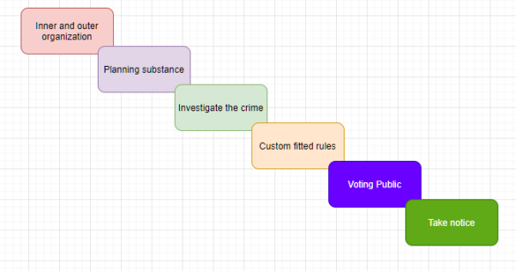

# Detail discussion on selected model

## Internal Combined Distributed and Centralized CSIRT

In this illustrate a committed, centralized CSIRT is built up interbank gathered people that passed on all through the organization in several dispersed goals. Centralized gather gives top-level examination and endorses recovery and help strategies. It in addition gives event, frailty, reinforce the dispersed gather people and other sectors of these wander. The scattered gather people at each area execute the strategies and deliver capacity in their ranges of obligation. This illustrate is insinuated to as the “collective CSIRT” all through the remaining of this document.(Schultz Jr et al., 1990)

### Maximize the performance

This illustrate maximizes the utilization of already available staff in imperative regions all through the organization with the all found arranging capability of the committed bunch to supply a huge managing of the security perils and development influencing the voting statistic. It has organization support in consigning required resources in the midst of times of crisis.(Schultz Jr et al., 1990)

It builds on the establishment and capacity inside the adjacent zones where the passed on bunch people energize event examination and reaction . The CSIRT reacts to details of unordinary activity or other event reports, takes portion in event and defenselessness examinations, credits skill in evaluation or assessing the security of the wander, and performs a proactive portion in declaring computer security mindfulness and planning all through the organization.(Tan et al., 2003)

* Centralized team

The illustrate gives a huge gather that can combine information from a huge collection of consecutive sources and quickly synthesize and spread it over the venture. The combined bunch works best , it has full pro to dissect activity and shared specialist to answer to event development since it happens. No enterprise-wide action is taken or endorsed without the support of the CSIRT administrator and conceivably upper organization (Guttman & Roback, 1995)

The bunch as well has the pro to maintain recovery and moderation methods with the support and consent of the organization. Divisional and valuable unit bosses are educated of any activity to be taken in their zones and are included inside the decision-making handle to choose how to execute a reaction.

### Supported Constituencies

This centralized appear have the same issues as the CSIRT on the off chance that the voting statistic may well be a gigantic firms with various associate or reinforcement groups.46 group in this case, in show disdain toward of the truth that seen as parcel of the identical parent substance, each accomplice or backup might have its have organization structure, courses of action, methodologies, and pro, or in fact its claim inner CSIRT.

This may cause issues in how much pro the combined CSIRT has over the frameworks, frameworks, and occurrence dealing with endeavors insides the work and may as well cause issues in influencing a solid level of response over these dissimilar units. In show disdain toward of the reality that a combined CSIRT can work in this organizational circumstance, a arranging illustrate may work predominant.(Ruefle et al., 2014).

### Organizational Structure

The combined bunch highlights a central region close to and reports to a high-level chief . The administrator or designee talks to the CSIRT in any administrational works out and bunches related to computer issues, interior as well as remotely. There's for the foremost portion a small, centralized middle staff and after that the scattered people are scattered all through the organization.(Wack, 1991)

### Multitude ways

The gigantic number of ways that joined CSIRT can be planned with regard to work assignments. (Grance et al., 2004; Guttman & Roback, 1995)

➢ One way the collective bunch perform all examination work and assignment the scattered gather to execute the response steps or methodologies at their locales.

➢ Another way the centralized bunch reasonable get event reports and after that allot the veritable examination and response to the reasonable spread bunch people based on valuable dominance and geographic area. (Tan et al., 2003)

➢ Another elective is to outsource all or parcel of the work of the centralized bunch to a third-party brief laborer, which is supervised by the CSIRT.

### Triage

Inside the combined appear, company can be publicized in two different structures. Inside the to start with, all details and requests includes under the CSIRT office and are categorized, sorted, and prioritized there.(Ruefle et al., 2014) Inside the minute, reports include into the passed on goals, where beginning is done and development, events, or requests that can be managed with by the dispersed gathering.

No concerns what hierarchy is utilized to supply the advantage, events and feebleness taking after data places may be accessible and open by all people CSIRT, centralized and passed on alike. The gather people get to the central database.(Creasey, 2013; Grance et al., 2004)

➢ reporting issues

➢ status checked

➢ update details

➢ hunt activity reports to recognize solutions

In spite of the fact that accessible by all people of the CSIRT staff, these databases are had and kept up by the central office.

### Available Services

The taking after zones delineate how CSIRT organizations can be given in a CSIRT. It is determine that each gather is distinctive, so these are common depictions based on recognitions of and talks with other bunches. The techniques that benefit is passed on acknowledge a certain level of establishment, staff, and equip, which are inspected in encourage sections.(Schultz Jr et al., 1990; Tan et al., 2003)

### Core Services

The center administrations characterizing this show don't vary essentially from those recorded earlier (core administrations for an inner distributed CSIRT) (core administrations for a centralized CSIRT).(Cichonski et al., 2012) The essential distinction is within the approaches by which the administrations are offered and overseen.

### Alerts and Warnings

In a illustrate, all cautions and takes note that are coming into the CSIRT or parent organization from other security pros, dealers, or CSIRTs are gotten by the centralized bunch parts of the CSIRT. Information is as a run the show gotten through many alloted focuses of contact details such as a CSIRT cell number or mail nom de crest. From there these cautions and takes note are spread to diverse centers of all through the admnistration, which are as a run the show the scattered people of the gather but which as well might consolidate system and arrange executives, exchange executives, or security bunches at spread districts.

### Incident Analysis

### The strong CSIRT joins a complete time, committed, gather with a spread gather that conclude on existing dominance over the undertaking. A bit like the strong CSIRT, the collective CSIRT assets to arrange occurrence examination to urge it what is happening over the Endeavor, and to work with the neighborhood chairmen to actualize event reaction exercises as required.(Schultz Jr et al., 1990)

### Attacks and Artifact Response Collaboration

Fair rather the combined bunch, a collective CSIRT is prevalent arranged a safety or scattered bunch to perform viable attacks and artifact response coordination, given the basic capacity exists inside the bunch. With committed resources, the gather component of the CSIRT can allow comprehensive taking after, recording, and spread of information to the undertaking. By joining together the information collected, the gather is better able to recognize comparative attacks, artifacts, mishandle, designs, and designs. (Creasey, 2013)

### Potential threats

Potential cutting edge threats to the undertaking can as well be recognized. In this illustrate, it is basic that the gather have capacity or nature with all stages and working systems utilized inside the organization.(Cichonski et al., 2012) On the off chance that this not exist interior the centralized bunch component, at that point there must be components in put to combine with the spread gather people or other organizational specialists who can grant the required data.

### Additional Services

In development to its middle organizations, a CSIRT may select to offer other organizations. The taking after organizations are those most likely to be given. (Tan et al., 2003)

➢ Occurrence Response on Area

➢ Interruption Revelation Organizations

➢ Powerlessness and Artifact Examination

➢ Security Audits or Assessments

➢ Setup and Bolster of Security Instruments

➢ Advancement of Security Instruments

### Staff

A collective CSIRT gives a collective staff that commits 100% to event response organizations. The spread bunch supplements and supports the CSIRT middle works out on a half and full introduce. A combined CSIRT gives a centralized staff that commits 100% of their time to event response organizations. The spread bunch supplements and supports the CSIRT middle works out on a full or half premise.

The staff contains the taking after people:

➢ boss allotted reinforcement to staff

➢ one administrative reinforce individual

➢ a few chairmen or others who have involvement in incident/vulnerability managing with exercises.

➢ one or more system chairmen to supply establishment support .

➢ one or more work region staff. These staff can besides perform triage and can be shared with other parts of the organization.

➢ Adequate dispersed staff (number chosen by parent organization) with reasonable fortifications recognized. The staff contains the taking after people:

➢ boss allotted reinforcement to staff

➢ one administrative reinforce individual

➢ a few chairmen or others who have involvement in incident/vulnerability managing with exercises.

➢ one or more system chairmen to supply establishment support .

➢ one or more work region staff. These staff can besides perform triage and can be shared with other parts of the organization.

➢ Adequate dispersed staff (number chosen by parent organization) with reasonable fortifications recognized.

### Equipment

Equipments are required to supportss centralized CSIRT people This joins (but isn't limited to) the taking after: (Schultz Jr et al., 1990)

➢ office places and furniture (work zones, copier, supplies, etc.)

➢ computer perform operations and exercises

➢ Lab faciliities

➢ tour and residential equipment (for more distant get to, planning, and on-site visits)

### Infrastructure

The system gives a better environment for CSIRT daily basis operations. This join (but isn't confined to) the taking after: (Wack, 1991)

➢ physical safety and security

➢ ensured control resources (on the off chance that appropriate)

➢ a hard or apportioned organize to restrict the CSIRT orchestrate from the other of the organization

➢ arrange security

➢ secure intranet

➢ a energetic and safe taking after system (bother ticket system, social database, etc.)

➢ secured store for putting absent and recording all event and feebleness information

➢ safe communications

➢ web administrations

➢ encryption innovations

➢ infection confirmation and checking computer program

➢ secure fortifications and capacity for CSIRT information

### Constraints

### The essential objectives to illustrate the inconvenience of working and working on a scattered bunch over a collection of geological and local zones. Loots of challenges join ensuring that the dispersed and centralized staff effectively and actualizing a input instrument to ensure that response endeavors are carried out concurring to the CSIRT’s guidelines.(Creasey, 2013).If this spread sectors of the organization are in other countries or are confined auxiliary companies, in addition be troubles in arranging exercises since of contrasts in courses of action, tongues, cultures, and zones.

### Strengths and Weaknesses of the Model

### Strengths

➢ CSIRT capacities are worked by a cantered, given staff who are arranged in computer response and recuperation.

➢ The passed on bunch people inside the field back the centralized group, giving capacity inside the adjacent systems and operations.

➢ There's encouraged event declaring, examination, and response over the venture. (Guttman & Roback, 1995)

➢ There's a centralized commitment for synthesizing and examining information to choose designs and plans for the total Endeavor. This gives a set of the vulnerabilities and event development over the voting public.

➢ There's a central store for event, defenselessness, and artifact data .

### Weaknesses

➢ The troublesome to encourage with all geographic and local areas.

➢ The centralized bunch might appear disengaged from the other organization.

➢ The scattered bunch may acknowledge commitment with other one

➢ The organization get to fill a few unused positions and purchase extra equipment. (Guttman & Roback, 1995)

➢ It is troublesome to choose the correct degree of the staff.

➢ The CSIRT will need to get bolstered subsidizing for central and scattered bunch expenses.

### Conclusion

The middle of the report is the introduction of a couple of security models that is giving a CSIRT power. Though there's no own who appear best, each of them have unmistakable uses for a particular circumstance or place. Care should taken to expound on the portrayal of conceivable organizations to help you make a fitting assurance of a appear in terms of a bundle of administrations. It is imperative to notice that there's no basic answer of appearing would best fitted an organization; each firms structure and prerequisites must be carefully designed. In addition, while not each organization will fit a particular illustrate for a CSIRT, each and every organization ought to be organized to entertain computer issues scenes and issues of daily operations. The middle of this report has been the presentation of many organizational models for giving a CSIRT capability. While there's no one who appear best, each of them has unmistakable benefits for a particular circumstances.

When a computer issues snare on any firms happens, an interruption is determining, or lots of the computer threats event happens, this is basic for the firms to has quick or sensible deduces of reacting. The strategy of tending is require is to set up a formalized occasion reaction for Computer Safety Occasion Reaction Bunch. When an occasion happens, the objective of the company is to maintained and reduce any harmed, ensure demonstrate, permit fast and beneficial recuperation, anticipate comparable future occasions, and select up data into dangers against the organization. When a computer attacks assault on an firms happens, an interruption is noticed, or numerous other sorts of computer issues event happens, this is fundamental for the organization to must have a quick and productive gathers of reacting. Our procedure of tending this requirement is to the set up a standard occasion reaction capability or a Computer Safety and Security Occasion Reaction.

We have besides portrayed a number of of the issues in a firm is likely to come over inside the transport of event taking care of organizations. It is our believe that the portrayals for how movement of each advantage might work interior the models has made a distinction .We have besides delineated many of the issues an organization is likely to come over inside the movement of event taking care of organizations. It is our believe that the delineations for how transport of each benefit might work interior the models has made a distinction you choose up distant way that is more grounded understanding of the qualities and obstacles of each appear.

# References:

Ab Rahman, N. H., & Choo, K.-K. R. (2015). A survey of information security incident handling in the cloud. *computers & security, 49*, 45-69.

Cichonski, P., Millar, T., Grance, T., & Scarfone, K. (2012). Computer security incident handling guide. *NIST Special Publication, 800*(61), 1-147.

Creasey, J. (2013). *Cyber security incident response guide*: CREST.

Grance, T., Kent, K., & Kim, B. (2004). Computer security incident handling guide. *NIST Special Publication, 800*(61), 11.

Guttman, B., & Roback, E. A. (1995). *An introduction to computer security: the NIST handbook*: Diane Publishing.

Jalal, I., Yusof, M. M., Shukur, Z., & Mokhtar, M. R. A Model for Afghanistan’s Cyber Security Incident Response Team.

Killcrece, G., Kossakowski, K.-P., Ruefle, R., & Zajicek, M. (2003). *Organizational models for computer security incident response teams (CSIRTs)*. Retrieved from

Mitropoulos, S., Patsos, D., & Douligeris, C. (2006). On Incident Handling and Response: A state-of-the-art approach. *computers & security, 25*(5), 351-370.

Ruefle, R., Dorofee, A., Mundie, D., Householder, A. D., Murray, M., & Perl, S. J. (2014). Computer security incident response team development and evolution. *IEEE Security & Privacy, 12*(5), 16-26.

Scarfone, K., Grance, T., & Masone, K. (2008). Computer security incident handling guide. *NIST Special Publication, 800*(61), 38.

Schultz Jr, E. E., Brown, D. S., & Longstaff, T. A. (1990). *Responding to computer security incidents: Guidelines for incident handling*. Retrieved from

Tan, T., Ruighaver, A., & Ahmad, A. (2003). *Incident Handling: Where the need for planning is often not recognised.* Paper presented at the 1st Australian computer, network & information forensics conference.

Wack, J. (1991). Establishing a Computer Security Incident Response Capability (CSIRC). *NIST Special Publication, 800*(3).